POS-distribution summary

* Every speech is ACTIVE

More verbs than adjectives

Verb proportion over the speeches:

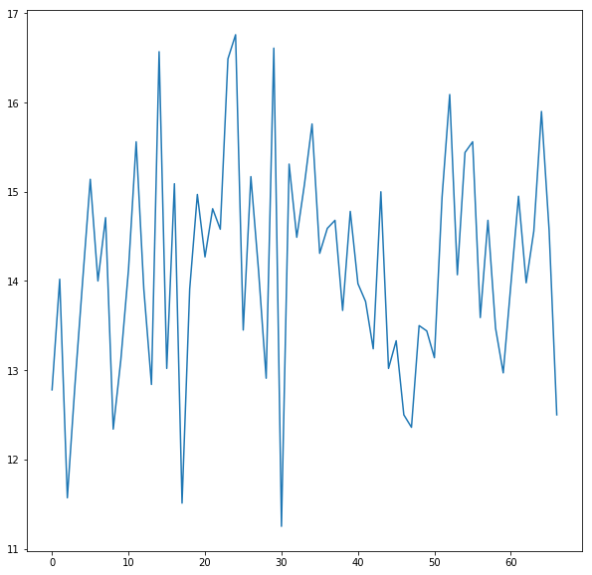

Noun-proportion over years

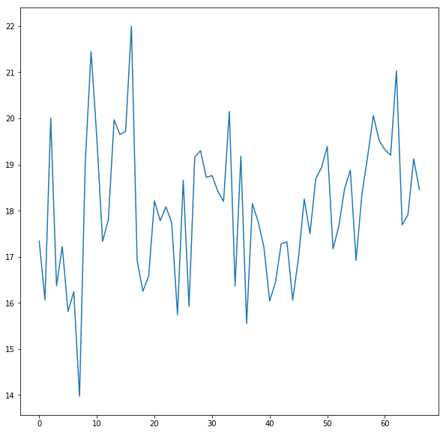

Name proportion over years:

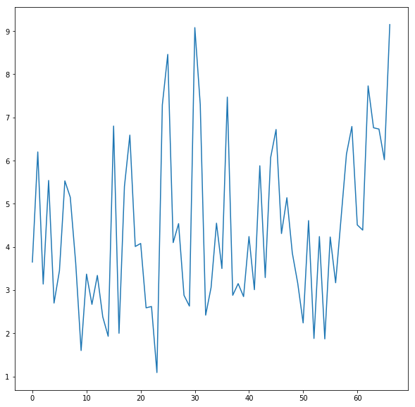

Pronoun count:

[goes down 🡪 delve into this]

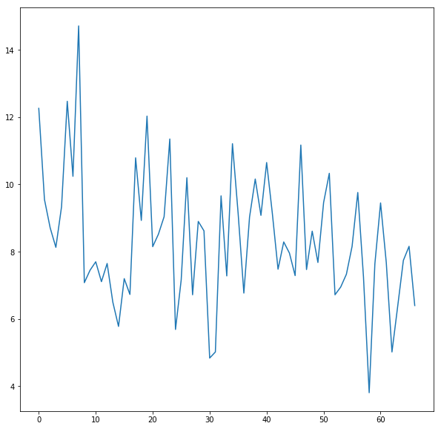

Adjectives:

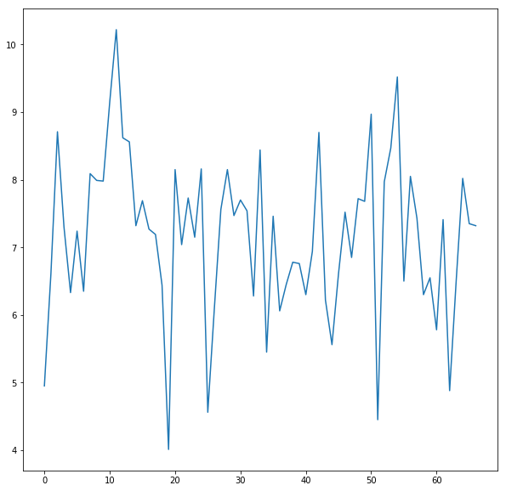

Adverb:

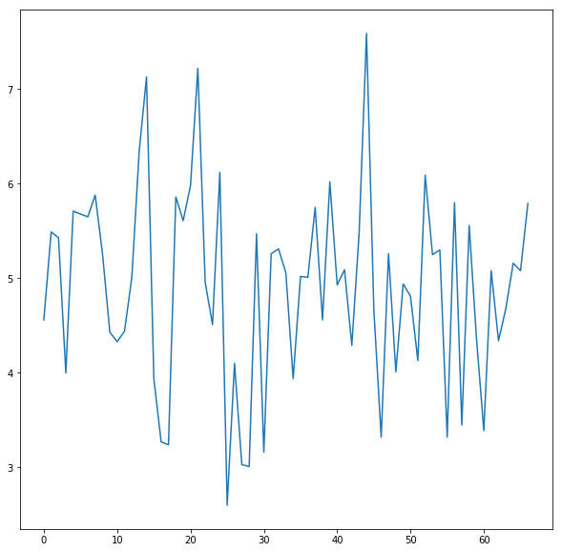

Determiner:

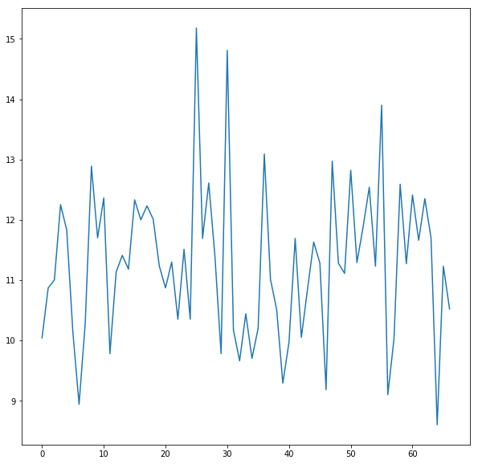

Preposition:

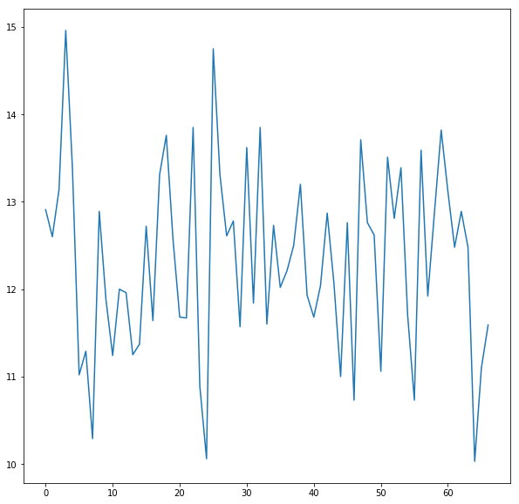

Conjunction

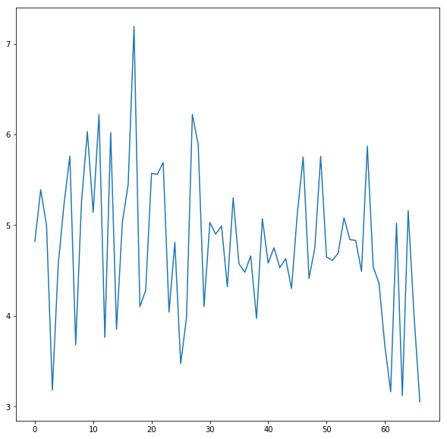

-gone down a bit (sign that its less complex?)

-this alongside MSL going down a bit